***Fly Creeker***

**NEWSLETTER of the FLY CREEK AREA HISTORICAL SOCIETY (FCAHS)**

**www:https//flycreekareahistoricalsociety.org**

**President: Greg Crowell, 607-547-2802; hfcrowell@gmail.com**

**Editor: Bill Deane, 607-547-4426; billdeane14@gmail.com**

**VOLUME 37, ISSUE 3 * SUMMER, 2025**

**NEWS BRIEFS**

* **Walking the Walk …** It may be over by the time you read this, but this weekend Dr. Cindy Falk will be leading another walking tour of Fly Creek, this one covering sites north of State Highway 28. It will be held on Sunday, July 13 at 3 PM, and the cost is $10/person. Call 607-547-8881, or go to otsego2000.org for details. Other 2025 Historic Preservation Series tours are scheduled at Hartwick, Roseboom, Middlefield, and Cooperstown.
* **Brochure Thing …** The FCAHS is one of 26 area museums/collections featured in a new brochure, “Historic Trails Otsego County Map.” The colorful guide was produced by Otsego250, the Otsego County Board, Levi Anderson (Otsego County Planning GIS Coordinator), and Helen K. B. Rees (Oneonta Chapter DAR & Swart-Wilcox Museum). They have put us on the map!
* **Stacking up a Profit …** The May 4 pancake breakfast grossed $1,802 for the Society, breaking the record set last fall. In addition, the 50-50 raffle netted us another $126, with Laurel O’Brien winning the grand prize. Thanks to event chair Tony Kroker and all the volunteers and donors who made this such a success! The fall event, newly christened the “Country Breakfast,” is tentatively scheduled for October 5.
* **Rough Roads Spoil Road Show …** Due to flash-flooding and road closures in Bainbridge on June 22, appraiser Chris Brown was unable to make it to our Antique Appraisal & Museum Day event. We did have several area collections and museums represented in our building, and many visitors admiring them. And we collected some $200 in donations. We hope to try again with Chris next year.
* **Hey, Lady! …** From August 7-10,the FCAHS will be hosting an exhibit of work by Fly Creek photo artist, Lady Ostapeck (1918-2017). The hours will be 4-7 PM on Thursday & Friday, and 11-3 on Saturday & Sunday, and the admission fee is $5. If you have any of her photos to lend, or stories about your experiences working with her, please share them with us!
* **Give Us an Inch, We’ll Take a Yard Sale …** Dora Cooke has stepped back after a quarter-century spearheading our annual Fly Creek Yard Sale Day, but Claire Kepner has volunteered to take over, with Dora’s guidance. The 2025 event will be on Saturday, August 23.
* **Time for Another Event? …** The FCAHS is planning to host a clock show in our building sometime in September. Watch for signs, news articles, and on-line postings for more details.
* **Building for Rent …** The FCAHS has set a fee schedule for rental of its building. For full-day use, the rate is $200 for profit-making organizations, $100 for 501 C (3) non-profit organizations, $75 for the general public, and $50 for FCAHS members; the respective rates for half-day use are $100, $50, $37.50, and $25. There is no fee for FCAHS-sponsored events. A security deposit equal to the user fee, and proof of $250,000 liability insurance, are required. There are also fees for a custodian ($15/hour, minimum $60), and for heat, if required ($50). Contact the FCAHS President for further information.

**(More news briefs on back page)**

**FROM THE ARCHIVES**

By Deecy Haviland

**(Editor’s note:** **This was Deecy’s final article featuring items from our FCAHS Museum collection, sent just days before her untimely death; see below.)**

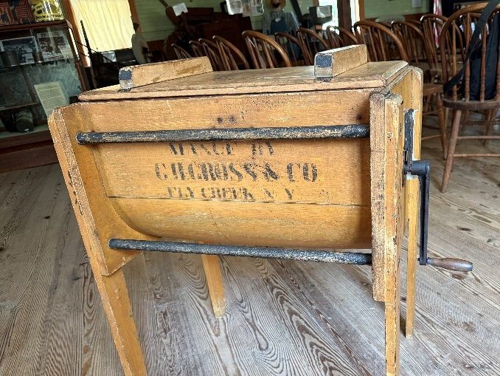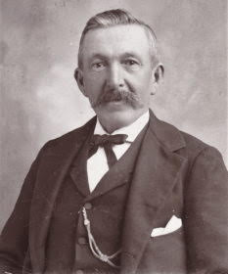

This butter churn in our collection was produced by Fly Creek entrepreneur George H. Gross (pictured at right) at the manufacturing property formerly owned by Ezra Badger. According to a 1958 article, the plant was located “just south of the four corners on the Toddsville road” (see page 72 of *Fly Creek Area History*).

George Gross was the son of Denison and Christina Hamilton Gross, who came from Connecticut and were early settlers in nearby Cherry Valley. There, Denison worked as a shoemaker and had a Last Shop on Main Street, and George was born in 1838.

As a young man George Gross worked as a blacksmith, mechanic, and carpenter, and married Mary, the daughter of Fly Creek’s blacksmith Abram Brooks. After the Civil War George and Mary had a son, Albert Eugene Gross. In 1871 George took over the old Badger Mill in Fly Creek, where he produced a wide variety of goods including butter churns.

When Mary died in 1905, she was buried in Fly Creek Valley Cemetery. George Gross moved to the Binghamton area to be near his son’s family in his later years. An avid angler, George was once fined for having an undersized trout in his possession. He paid the $25 fine and was declared “an honest fisherman” by the local paper!

When George Gross died in 1921, he joined Mary at the Fly Creek Valley Cemetery.

Sympathy to the family and friends of two long-time FCAHS members who died recently.

**Art Blessin** diedat his Fly Creekhome on May 24, 2025. A member since 2006, Art was 89.

Arthur C. Blessin was born November 18, 1935, in Locust Valley, Long Island, N.Y. His family moved to the Cooperstown area a decade later. Art graduated from Cooperstown High School and served three years in the U.S. Marine Corps, before marrying Beverly Bridger in 1961. In 1969, they bought land on Goose Street, Fly Creek, where they built their “forever home” and raised two children.

Art is survived by his wife, FCAHS member Bev, along with a daughter and two grandchildren.

**Denise “Deecy” Haviland** died suddenly on June 15, 2025. Deecy joined the FCAHS more than a decade ago, and was a very active member throughout that time. She contributed many articles to the *Fly Creeker* (see above) and *Fly Creek Area History*. Deecy served as our Treasurer from 2019-23, and as chair of our Archives and Research Committees ever since. In those roles she took pride in showcasing our collection and developing our museum. Deecy is survived by her husband, FCAHS member Ted Buhl. She will be sorely missed.

**MEETINGS & PROGRAMS**

The next three FCAHS monthly meetings are scheduled for July 23, August 27, and September 24, 2025. Meetings start at 6:30 PM at the FCAHS/Grange building at 208 Cemetery Road, Fly Creek.

In July, Patrick MacGregor, long-time Manager of Interpretation at Fenimore Farm, will present “Nineteenth-Century Medicine.” August will feature our annual reports and elections, preceded by a covered-dish dinner at 6:30. And in September, Milford Town Historian Frank Antonucci will tell us about “Fly Creek and the 121st Regiment Volunteers of the Civil War.”

The three most recent gatherings were held on April 23, May 28, and June 25, 2025. In April, Gilbert Lake State Park volunteer Rich Ranieri gave a fine PowerPoint presentation on the “History of the Civilian Conservation Corps,” particularly its work on building that local park in the 1930s. In May, Cherry Valley Town and Village Historian Susan Murray-Miller discussed “The Cherry Valley Massacre,” the historic Revolutionary War battle of November, 1778, involving Americans on both sides of the war (Patriots and Loyalists), Native Americans, slaves, and religious factions. And in a late substitution in June, Jessie Ravage gave an engaging, extemporaneous program on “Mills and Manufactories on Oaks Creek.”

**NEW AND IMPROVED!**

By Harriett Geywits

[Editor’s note: Harriett Geywits of Richfield Springs has done a lot of research on patents issued to Otsego County residents in the nineteenth and early twentieth centuries. She sent along these five by Fly Creek area residents. Full descriptions and diagrams of these inventions and patents have been added to our archives.]

* April 16, 1841, a “new and Improved Mode of Constructing Cooking-Stoves,” by John B. Bissell of Oaksville.
* July 10, 1866, “a new and useful Machine for Planing Sawed Shingles,” by Daniel Niles of Fly Creek.
* July 2, 1867, a “new and Improved Device for Supporting Hop-Poles,” by Norman C. Roberts and Ezra W. Badger of Fly Creek.
* April 15, 1884, a “new and Improved Chest of Drawers,” by Abe Lincoln Adams of Fly Creek.
* Dec. 16, 1890, a “new and useful Fruit-Gatherer,” by Daniel B. Randall and Henry W. Randall of Fly Creek.

 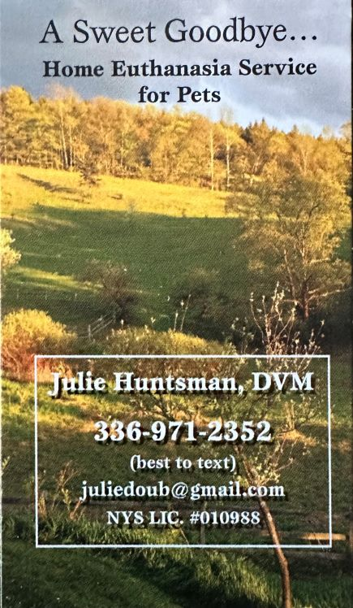 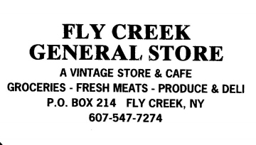

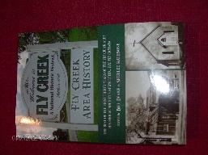***FLY CREEK AREA HISTORY***

Each issue, we will include an article from our 2022 book, *Fly Creek Area History*. The book is still available at the FCAHS/Grange building ($20 for members), and at the Fly Creek General Store and Fly Creek Cider Mill ($25 plus tax for the general public). Copies can also be mailed in the continental U.S. (library rate) for an additional $7 per book.

**SEWING UP A FLY CREEK HISTORY DISCOVERY**

By Tom Heitz, Spring 2005

While conducting research at the New York State Historical Association Library I stumbled across an item of special interest to area historians. A series of advertisements running in *The Freeman’s Journal* establish that Isaac Merritt Singer, who later co-founded the Singer Sewing Machine Company, spent time in the Fly Creek area. Singer worked at the shop of George W. Potter on Oaks Creek, one mile from the Fly Creek village, in the summer of 1833.

Singer, the youngest son of Adam Singer and Ruth Benson, was born in the hamlet of Johnsonville, in the town of Pittstown, Rensselaer County, October 27, 1811. His parents divorced when he was 10 years old and, after his father remarried, Singer did not get on well with his stepmother. At the age of 12 he went to live with an older brother in Oswego, NY. Working in his brother’s machine shop, Singer learned the trade that ultimately brought him great fortune.

At the age of 19 in 1830, Singer married Catharine Maria Haley, a 15-year-old girl, and it is believed they moved to New York City in 1831 where they lived with her parents. Catharine gave birth to their first child, William, in 1834. Very little is known of this early period in Singer’s life, but the advertisement that appears half a dozen times in *The Freeman’s Journal* (copied below) establishes his presence in the Fly Creek area for at least a period of weeks.

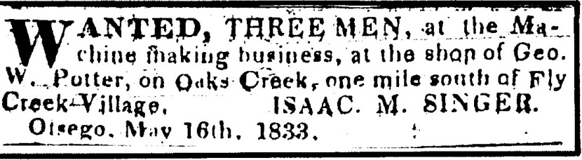

According to the 1830 census records, Potter was a married man in his 20s with a young daughter and a mother or mother-in-law living with them. By 1840, there is no census record for Mr. Potter.

The same ad signed by Isaac M. Singer is repeated through June into early July of 1833. Singer’s name also appears in a list of persons with letters waiting for them at the Cooperstown Post Office, published in the July 1 and July 8, 1833 editions of the newspaper. By October 1833, when the next mail list appears, Singer’s name has disappeared. As far as can be determined, Isaac Singer never returned to the Cooperstown area after 1833.

Exactly what Singer was doing at Potter’s shop is unclear. He may have been experimenting with an early version of a rock drilling apparatus that he eventually patented in 1839. In any event, Lin Van Buren, a GenWeb Administrator and one of Singer’s biographers, has confirmed that the advertisement is new information about his early adult years.

Singer is commonly mistaken as the inventor of the sewing machine. While he came to hold numerous patents relating to sewing machine parts and designs, he was only one of several inventors who eventually found it profitable to pool their patents to produce sewing machines that worked reliably. Singer’s relationship with lawyer Edward Clark did not begin until the 1840s.

Clark, who was born December 19, 1811, at Athens in Greene County, NY, was educated at Williams College. He studied law for three years and in 1833 he began the practice of law in Poughkeepsie, NY. Clark married Caroline Jordan, eldest daughter of lawyer Ambrose Jordan, in May, 1837 and formed a law partnership with his father-in-law. In May, 1838, Jordan & Clark moved their practice to New York City. Singer became a client of the firm’s in 1848, and this affiliation became the key to the Clark family’s wealth. In 1855, Edward Clark purchased a farm property then known as Apple Hill in the village of Cooperstown. It is located on the east side of River Street, where Edward’s descendant Jane Forbes Clark resides today.

**\* * * * \***

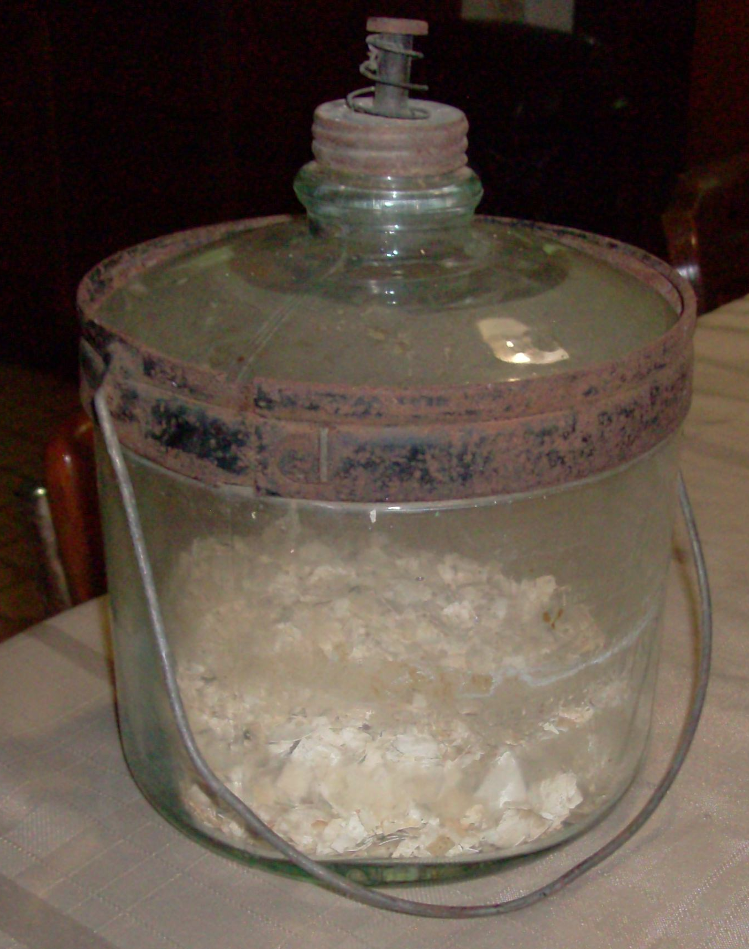

**WHAT IS IT?**

Chris Kjolhede found the above item in the basement of the Fly Creek Methodist Church, and wonders what it is and/or what it was used for. The jar, measuring eight inches in diameter, contains what appear to be crushed egg-shells. Can anyone solve this mystery?

**NEWS BRIEFS (Continued from page 1)**

* **News about Newbies …** Welcome to our newest members, James & Nicki Andrews, Jay Bosley & Hudi Podolsky (P), David Buddle, and Janette Lyons! We also received a renewal from Andrew & Melissa Marietta (P). (P = Patron of History membership.)
* **Archivist Needed …** The FCAHS needs people to take over and/or help with two very important committees. The Archives Committee is “responsible for collecting, cataloging, caring for, arranging, and repairing books, manuscripts, newspapers, artifacts, relics, and other historical material,” and the Research Committee is “responsible for the coordination and guidance of genealogy and other research.” Please let us know if you are willing and able to help.
* **Making News …** Thanks to Darla Young, the FCAHS was featured in the June 19 and July 3 issues of Cooperstown’s *Freeman’s Journal*. Borrowing from our web-site and newsletter, the *Journal* discussed our Society’s history and upcoming events, and our dear, departed charter member, Freida Snyder.
* **Off the Rails …** Greg Crowell installed a second set of hand-rails along the stairs to the second floor of our building, to make them safer for people coming and going from one floor to the other. Thanks, Greg!
* **Pastor Present …** The Rev. Dr. Wilson Jones became the new pastor of the Fly Creek United Methodist Church in April. Previous pastors are listed in *Fly Creek Area History*, pages 101-02.
* **Getting on Board …** The next quarterly meeting of the FCAHS Board of Trustees is scheduled for October 8 at 3 PM at the Town building. Members are welcome to attend.

**---------------------------------------------------------------------------------------------------------------------**

**FLY CREEK AREA HISTORICAL SOCIETY**

**P.O. Box 87**

**Fly Creek, NY 13337**