***Fly Creeker***

**NEWSLETTER of the FLY CREEK AREA HISTORICAL SOCIETY (FCAHS)**

**President: Greg Crowell, 607-547-2802; hfcrowell@gmail.com**

**Editor: Bill Deane, 607-547-4426; billdeane14@gmail.com**

**VOLUME 36, ISSUE 4 * FALL, 2024**

**RAISING THE ROOF**

Our historic building’s roof is in urgent need of repair, and (based on estimates we have received so far) will cost us upwards of $30,000. There are other imminent building repair needs as well. We will be exploring grants to help with these, but in the meantime are seeking donations from the community. As we are a 501(c)(3) non-profit organization, contributions are tax-deductible. Please consider donating what you can, and getting the word out to other community members. We have added a “building repair fund” line at the end of the renewal application on page 5. Also, we are seeking members for our Finance Committee to help in applying for grants. Thank you all for your support!

**NEWS BRIEFS**

* **Rescheduled …** So as not to conflict with a Fly Creek Fire Company event, our fall Pancake Breakfast has been rescheduled to this Sunday, October 13, 8 AM until noon.
* **Taking Stock …** Our building is loaded with surplus “stuff” – chairs, plates, papers, etc. – mostly upstairs. Some of it can be discarded, while some may be suitable for sale, donation, or adding to our museum collection. On Wednesday, October 16 at 10 AM, we will be having a work day to start the process of taking inventory, sorting, and relocating this stuff. Walk-in volunteers are welcome!
* **Due-ly Noted …** Reminder: 2025 dues are payable by January. An application appears on page 5, and a list of paid-up members will be included in the next newsletter. And Christmas is coming – how about a gift membership for that friend or family member who hasn’t gotten around to joining? Thanks for your continued support. And welcome to our newest members, Darshan Newell Fresco, Brian Leyde, and Tassha Rathbone & family!
* **What a Tangled Web …** Check out the new FCAHS web-site at flycreekareahistoricalsociety.org. The Trustees decided to hire Kip Shaw of Sunny Web Shops to design it, and Sharon Kroker and Bill Deane worked with him to get our important content on it. Keeping it up-to-date will be an ongoing process; feedback, help and ideas are welcome!
* **Typo …** Apologies to Layne Weir, who was misidentified in the Summer issue. She serves with Kathy Snyder as co-chair of the Program Committee.
* **Passing the Pen …** After 13 years as our Secretary, Dora Cooke has retired. Dora nearly tripled our old record of five years in that role, and took minutes for more than 150 regular and Trustees’ meetings since 2011. Claire Kepner has graciously agreed to take over the Secretary position, a role she previously filled from 2003-08, and was formally elected to in August. Huge thanks to Dora, and welcome back, Claire!
* **Jim Seward, 1951-2024 …** We were sorry to hear of the July 27 passing of former State Senator Jim Seward, a long-time friend of our Society. Jim spoke to us about the history of the Erie Canal on April 25, 2001, one of our best-attended programs ever. He was also instrumental in getting us a $20,000 grant from the New York State Senate for building repairs in 2002.

**(More news briefs on page 6)**

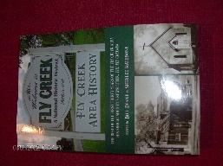***FLY CREEK AREA HISTORY***

Each issue, we will include an article from our 2022 book, *Fly Creek Area History*. A few copies of the book are still available at the FCAHS/Grange building ($20 for members), and at the Fly Creek General Store and Fly Creek Cider Mill ($25 plus tax for the general public). Copies can also be mailed in the continental US (library rate) for an additional $7 per book.

**NATTY BUMPPO SLEPT HERE …**

By Jim Atwell (from 1995 “From Fly Creek” *Freeman’s Journal* column), Spring 2003

Something intriguing in the 1878 *History of Otsego County*. The book says that the prototype for James Fenimore Cooper’s Natty Bumppo was an old man who wandered in and out of Cooperstown during Cooper’s youth. His name was David Shipman, and he lived three miles out of the village on the east bank of Oaks Creek, about halfway between Toddsville and Fly Creek hamlet. That puts his cabin about where Oaks and Fly Creeks converge, just above Fork Shop Road.

And it means that the original Leatherstocking lived his later years not a mile from my house, which was already standing in those days. Of course I like to imagine the rough-cut old recluse standing in my dooryard, drinking from a tin dipper, or perhaps inside on a bleak November day, warming by the fireside.

It’d be stretching it to say, “Natty Bumppo slept here” – but, who knows? Maybe a March nor’easter, sweeping in a wall of snow on blizzard winds, blocked him from getting home one evening. Maybe old Bumppo spent a night snoring by my hearth, scenting the air with the deerskin he wore and (given his likely hygiene) with his own hide.

But the *History* adds another detail, one Cooper chose to ignore. For a while Bumppo, i.e., Shipman, had a wife sharing the cabin where the creeks join. She died well before David, and he brought a Baptist minister from Hartwick to bury her close by their home. The minister was outraged by the site David had chosen. It was boggy land (still is), and as the grave was dug, it half filled with water. Shipman was adamant; she must be buried by their home.

“And if I live to die,” the book quotes him, “I expect to be buried there myself.”

It’s Shipman’s “if” that stops you. ’Most all of us, after all, manage to live long enough to die. But for David Shipman, it seems to have been possibility rather than certainty. That’s disarming. Even endearing.

Well, David did live to die, though it happened many years later. But, sad to say, they didn’t lay him to rest beside his wife. The 1878 *History* says he was buried in the Adams Cemetery, which now fronts on County Highway 26. By 1878, the exact site in the cemetery had already been forgotten.

I think of the original Bumppo when I walk past that cemetery. And when I hike through the wet stretches where Oaks and Fly Creek converge, I think of his missus, given a burial at sea, though a good ways inland. Left there in another lost grave to carry on the long voyage alone.

Leatherstocking wouldn’t have wanted that. I’m sure of it.

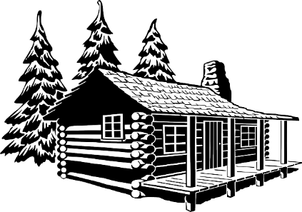

**MEETINGS & PROGRAMS**

The final two FCAHS meetings of 2024 are scheduled for October 23 and November 20 at 6:30 PM. October’s will be held at the FCAHS/Grange building on 208 Cemetery Road, and feature Bruce Markusen telling “Cooperstown Ghost Stories.” November’s will be held in the Fellowship Hall (basement) of the Fly Creek United Methodist Church, with Jim Loudon screening his documentary about the “Leatherstocking Route” trolley line.

The three most recent gatherings were held on July 24, August 28, and September 25. In July, we heard from Dan Zimmerman, Otsego County Soil & Water Conservation District Forester. He discussed “The Emerald Ash Borer,” which he called the biggest threat to the destruction and ultimate extinction of ash trees in Fly Creek and the entire northeastern United States. August featured our Annual Meeting, including a covered-dish dinner, yearly committee reports, and elections for President (Greg Crowell), Vice-President/Board Chair (Bill Deane), Secretary (Claire Kepner), and one Trustee (Liz Susman). And in September, nearly 40 people heard Martin Tillapaugh, proprietor of Tillapaugh Funeral Services, telling us about interesting and bizarre “Victorian Funeral Customs.”

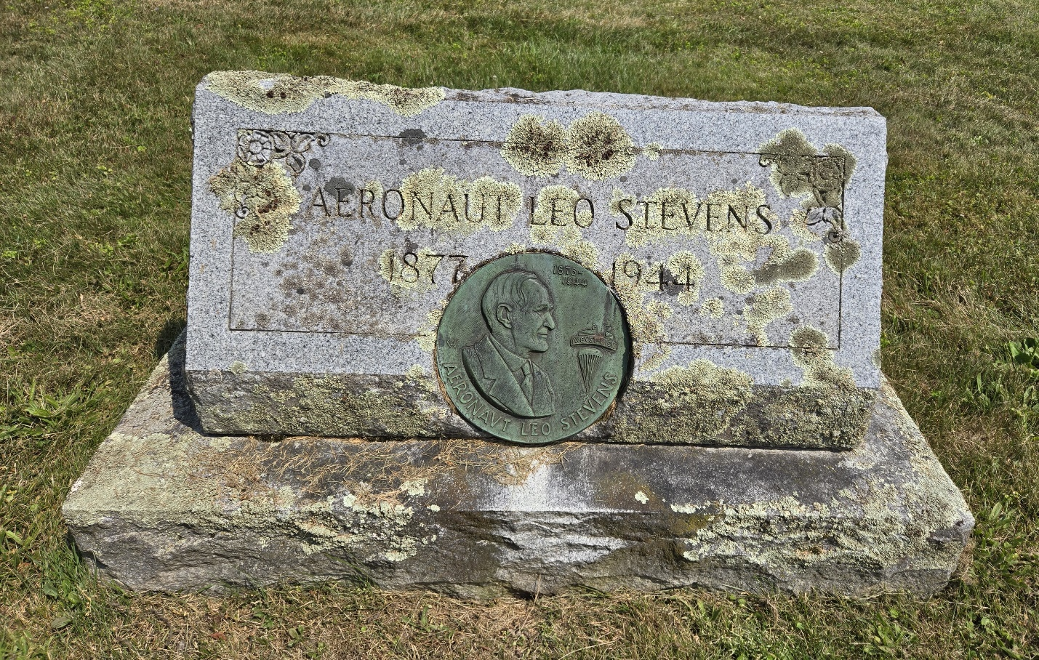

Famed aviator A. Leo Stevens lived in Fly Creek the last 17 years of his life, and is buried in the Fly Creek Valley Cemetery. His story is told in *Fly Creek Area History*, pages 151-152. (Photo by Judy Gibson)



**LETTERS TO THE EDITOR**

The *Fly Creeker* will print letters of general interest about area history, the Society, or the newsletter itself. The Editor reserves the right to edit letters for grammar, space, etc. Address correspondence to Bill Deane, at 408 Christian Hill Road, Cooperstown, NY 13326; or e-mail to billdeane14@gmail.com.

**FROM THE ARCHIVES**

By Deecy Haviland

**Each issue, we will plan to feature an item from our FCAHS Museum collection. The museum is open during FCAHS monthly meetings and special events, and by appointment (deecy2650@gmail.com).**

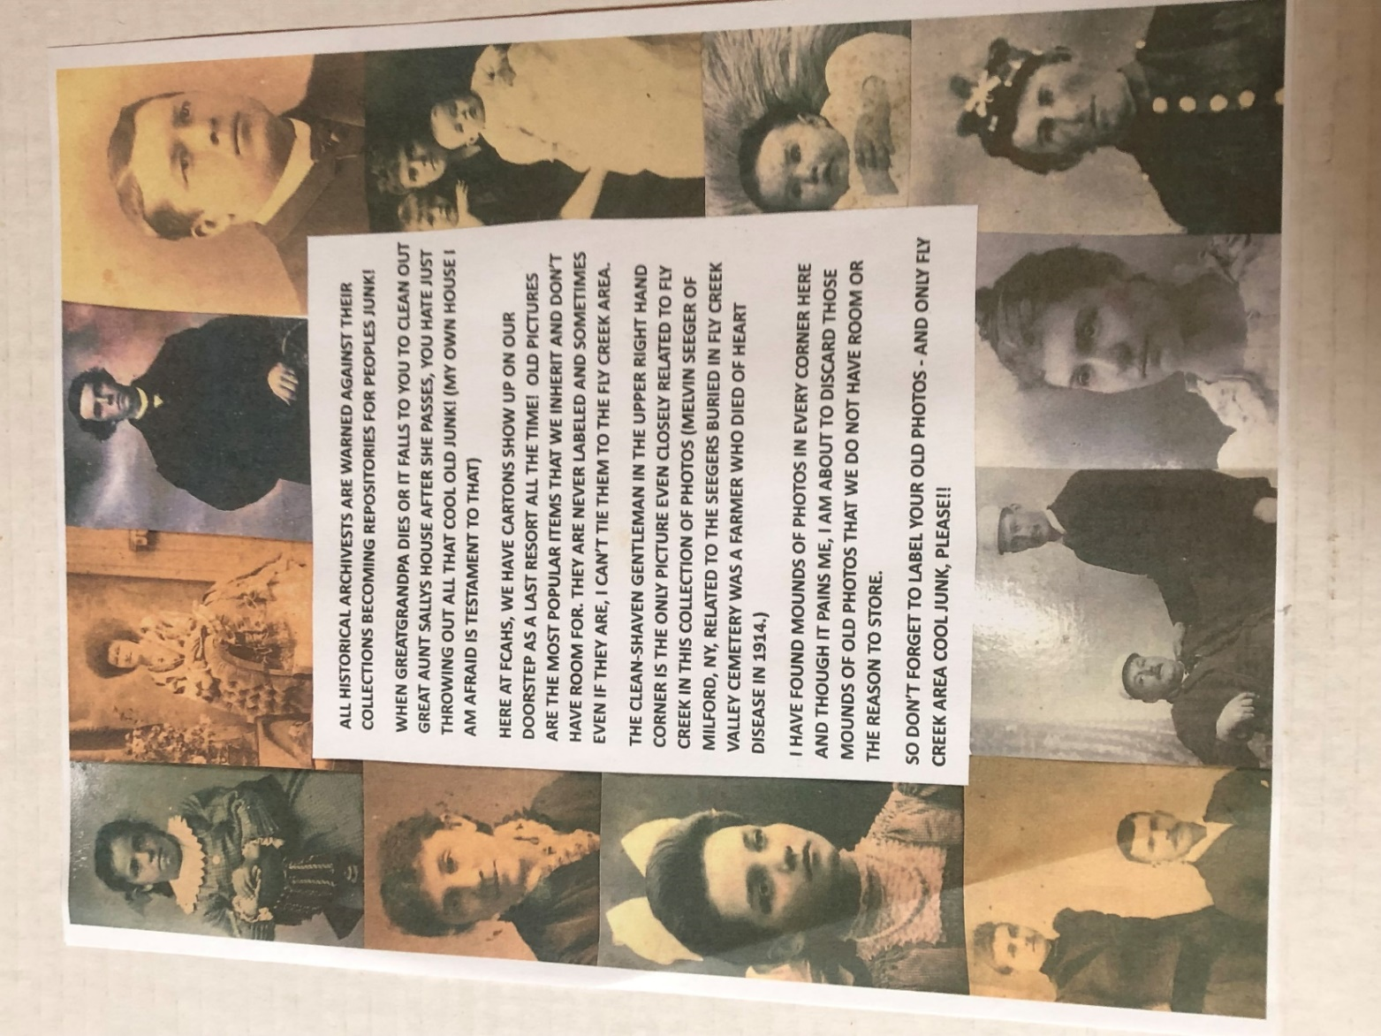

Editor’s note: The photos Deecy refers to were never accessioned into our collection. The FCAHS would not unilaterally discard something that was properly donated, accepted, and accessioned.

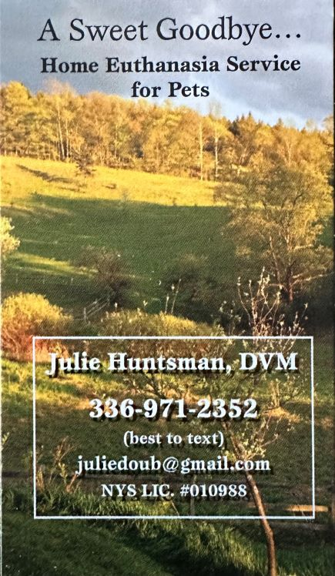 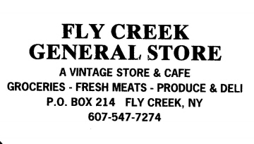

--------------------------------------------------------------------------------------------------------------------------------------------

**2025 MEMBERSHIP APPLICATION**

**FLY CREEK AREA HISTORICAL SOCIETY**

**P.O. Box 87, Fly Creek, NY 13337**

Name(s): _______________________________________________________________ Renewal ___ New ___

Address: _____________________________________________________________________________________

Telephone: ( ) - e-mail address: ______________________@_____________________

Please register me as a junior member of the FCAHS (age 21 or under). Enclosed is a check for $5.

Please register me as a member of the FCAHS. Enclosed is a check for $15.

Please register us to a family membership (note: this extends to all family members living in one domicile). Enclosed is a check for $25.

Please accept the enclosed tax-deductible donation, in the amount of $_____ (minimum $30 for individuals or $40 for families), and enroll me/us as a contributing/sustaining member(s).

Please register me as a “Patron of History.” Enclosed is a check for $50.

Please register me for a sustaining business/professional membership (includes a business card-sized ad in the *Fly Creeker*). Enclosed is a check for $90.

Please register me as a Lifetime Member (individuals only). Enclosed is a check for $500 (to be deposited into the Society’s Endowment Fund, or into one of the Society’s general or special funds, at the discretion of the member).

Please accept the enclosed donation, in the amount of $________ toward the building repair fund.

**NEWS BRIEFS (Continued from page 1)**

* **Lionizing Local Legends …** Jim Atwell and the late Anne Geddes-Atwell were honored at a FCAHS-sponsored event at our building on August 17. More than 50 people attended to wish Jim a happy 86th birthday, and reminisce about the impact he and Anne have had on our community. Jim was a founding member of the FCAHS, serving as President from 1996-2000 and Trustee from 2002-06, and was instrumental in our acquiring the building. He also authored countless local newspaper columns and three books, mostly about his life in Fly Creek (another one is featured in this issue). Anne, who died in 2020, served briefly as our Secretary, and as Town of Otsego Supervisor from 2012-16.
* **Number One …** Congratulations to the Fly Creek Cider Mill, which was named “America’s Number One Cidery” by *USA Today*! The honor was announced on August 30, in connection with the newspaper’s annual “Best Readers’ Choice Awards.”
* **Super Men …** Ben Bauer, Town of Otsego Supervisor since January, 2022, vacated his post in August to move south. Jay Bosley was appointed in the interim. A list of previous Town Supervisors appears on pages 239-241 of *Fly Creek Area History*.
* **Consign Me Up! …** Christine DiNigro has opened “Christine’s Consignment Store” at the former Kim’s Kut & Style location in Fly Creek. It is a women’s used clothing consignment shop, approved by the Town Planning Board in October.
* **Wide Area…** Reminder: we are the Fly Creek *Area* Historical Society. When the Society was formed in 1989, we explained that the area includes “Fly Creek, as well as the neighboring hamlets of Oaksville, Pierstown, Fly Creek Valley, Forkshop, Toddsville, Index, Christian Hill, Phoenix Mills, and rural Otsego.” Which was a long way of saying “The Town of Otsego other than Cooperstown.”

**---------------------------------------------------------------------------------------------------------------------**

**FLY CREEK AREA HISTORICAL SOCIETY**

**P.O. Box 87**

**Fly Creek, NY 13337**