***Fly Creeker***

**NEWSLETTER of the FLY CREEK AREA HISTORICAL SOCIETY (FCAHS)**

**www:https//flycreekareahistoricalsociety.org**

**President: Greg Crowell, 607-547-2802; hfcrowell@gmail.com**

**Editor: Bill Deane, 607-547-4426; billdeane14@gmail.com**

**VOLUME 37, ISSUE 1 * WINTER, 2025**

**PUTTING A LID ON IT**

Our historic building’s roof is in urgent need of repair, and will cost us more than $30,000. There are other imminent building repair needs as well. We will be exploring grants to help with these, but in the meantime are seeking donations from the community. As we are a 501(c)(3) non-profit organization, contributions are tax-deductible. Please consider donating what you can, and getting the word out to other community members. We have added a “building repair fund” line at the end of the renewal application on page 7. Also, we are seeking members for our Finance Committee to help in applying for grants. Thanks to those who have already contributed a total of $5,980 (including a particularly generous gift from the Harringtons), listed below, alphabetically:

Floyd & Patrice Bourne

Bill Deane

Fly Creek Cider Mill

Carol Goddard Hanlon

George & Diantha Harrington

Merritt & Elaine Harvey

Martha Helfand

Sharon & Tony Kroker

Fred & Toby Marienfeld

Bonnie Sharpe

Les Sittler

Mary Winne

**NEWS BRIEFS**

* **Due-ly Noted …** Final reminder: 2025 dues are payable by this month. If your name is not on the list on page 6, please use the application (or a copy thereof) on page 7 to renew your membership and keep getting our newsletter. Thanks for your continued support! And welcome to our newest members, Kevin Brogle, and Michael & Regan Schram!
* **Electronic…** We have been distributing the *Fly Creeker* electronically to many of our members, which saves us paper and postage. If you would like to get future issues that way, please e-mail the editor at billdeane14@gmail.com. Thanks.
* **Selling like hotcakes …** Our October 13 pancake breakfast grossed $1,732 and netted $1,357 for the Society, which we believe are records. Thanks to Activities Chair Tony Kroker and his tireless crew of volunteers, to local merchants (Fly Creek Cider Mill, Price Chopper, Stewarts, Grand Union, and Hannaford) who donated food and drink, and to all who stopped by on a dreary day with wallets open!
* **Revolving Door …** Another change to our Town of Otsego Supervisor: Jay Bosley resigned in October, and Ted Feury has been appointed as interim Supervisor through December, 2025.A list of previous Town Supervisors appears on pages 239-241 of *Fly Creek Area History*.

**(More news briefs on page 8)**

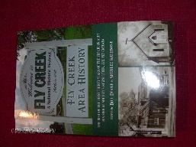***FLY CREEK AREA HISTORY***

Each issue, we will include an article (or two, in this case!) from our 2022 book, *Fly Creek Area History*. A few copies of the book are still available at the FCAHS/Grange building ($20 for members), and at the Fly Creek General Store and Fly Creek Cider Mill ($25 plus tax for the general public). Copies can also be mailed in the continental US (library rate) for an additional $7 per book.

**FLY CREEK VALLEY SCHOOL DAYS**

By Carolyn McLean, Spring 1996

The following is from a paper written by Edna Ainslie (1889-1972), daughter of Chester and Emma McRorie and refers to the Fly Creek Valley School:

“The first history of School District 15, as it was called in those days, dates back to 1842; in 1866 it was called Dist. No. 18, and in 1869 it was Dist. 11, as... it has been called ever since. These notes were taken from very sketchy accounts in an old trustees’ book (dating from 1842-1905 and now in the possession of Carolyn McLean). In 1842 there were two trustees, Albert Coats and William Turner. Teacher received $8.60 for summer term of 16 weeks. Public money received was $46.20. Possessions of the (District) were ‘1 pail, 1 broom, 1 basin, 1 chair, all in pretty good condition except the chair needs a new bottom.’

“First note of tax raised was in 1843 – amount $36.15. There were two terms during the year, summer and winter, and sometimes different teachers for each term. In 1850 public money was down to $27.30, taxes $38.92. Some items in the expense acct. were 15½ cd. wood, $1,162 ($75/cord); 2 panes glass, $ .22; ½-day’s work, $ .34.

“1854 – Elvira Pierce (who later married Menzo Bourne, and lived to age 105), mother of Mrs. Lewis (Emma) Mann, taught one term for $20.85. In March 1868, schoolhouse burned from ashes saved in unsafe containers and the school was held in the cheese house... then owned by Peter Van Valkenburg, trustee, for 5 weeks for which he was paid $5. This place, known as the Rose Farm now, is owned by Herbert Burdt. [Herb’s widow, Dylis Barré, reported in 2018 that Homer Rose built the original barn in 1888, and the Burdt family bought the property from Lyle Rose in 1943. Herb and Dylis opened the Fieldstone Farm Resort there in 1968, and sold it to John Sovocool in 1998. The original barn burnt in 1970, but its foundation is still intact, with a stone engraved “H. Rose 1888.”]

“In 1869 records show purchases of lumber and ‘orders on community’ for $700, so the conclusion is that the present schoolhouse was built at this time. Also, land bought of Martin Coats to enlarge ground for $15.”

Additional notes about this school: some of the maple trees around the building are said to have been planted by students on Arbor Days in the early 1900s, with bottles containing the names of these students placed at the roots. And, a teacher named J. Taylor House, aged 34 and in seemingly good health, dropped dead of a heart attack in 1916 while standing at the blackboard explaining a math problem (this may actually have happened at the Fly Creek school). The Fly Creek Valley school closed in 1946, and the building is now used for the Fly Creek Valley Grange.

**SLAVERY IN OTSEGO**

By Carolyn McLean, Autumn 2000

“For Sale, A BLACK WOMAN, who understands all kinds of work in a country house and kitchen, is capable and willing, has no bad qualities – is about 29 years of age. For terms, which will be reasonable, and other particulars, enquire of the Printer.”

So read a March 4, 1807 advertisement in Cooperstown’s *Freeman’s Journal*. Hard to believe, but the buying and selling of human beings was not entirely outlawed in New York state until 1827.

The U.S. census of 1790 indicates that there were eight slaves and fewer than 1,700 “free whites” in the Town of Otsego (part of Montgomery County until Otsego County was established a year later). Slave-owners included Gen. Jacob Morris (for whom the Town and Village of Morris are named), who had five slaves; and Abjah Gilbert (founder of Gilbertsville) and Tobias Honk, owners of one slave apiece. Honk’s identity is somewhat of a mystery, as there is no record of him in the New York state census of 1800, nor any death notice. The owner of the eighth slave has been lost to history, as part of the corresponding page is missing.

Judge William Cooper moved his family and two slaves to what became Cooperstown in the Fall of 1790 (probably after the census was taken), according to Alan Taylor’s book, *William Cooper’s Town*. The book also mentions that there were seven slaves in Cooperstown in 1803, with five of the village’s 62 households equipped with at least one.

On a more positive note, one Jedediah Peck reportedly assailed Jacob Morris in 1796 for “opposing the emancipation of New York State’s slaves.” Peck lived in the Town of Burlington, near the Town of Otsego line, along what is now State Highway 80. A colorful, outspoken advocate for the common man, he became one of the most influential persons of this area, gaining many important positions, including State Senator. [A State historical marker adorns his grave 1.6 miles east of the junction of State Highways 80 and 205, and it is featured in Chuck D’Imperio’s *Great Graves of Upstate New York*.]

A pioneer in regional African-American rights was Dinnah Jackson, “a free black woman” who in 1779 became the first Negro to own property in Albany. The process of abolishing slavery in this state began with a statute, decreeing that all children born to slave mothers in New York after July 4, 1799 would be freed – males at age 28, females at 25. All such births had to be registered. This statute was sometimes circumvented by sending pregnant slaves out of state just long enough to give birth. Another milestone in the emancipation process occurred in 1809, when slave marriages were recognized, legitimizing the children of slaves and prohibiting the separation of spouses. Also in 1809, Negroes could for the first time own and transfer property by will.

Quakers took the lead in emancipation efforts, followed soon after by Presbyterians. However, not all religious groups embraced these views. Some local wealthy Methodists reportedly broke away from their church to form new congregations, after refusing to consider giving up their slaves. One wonders how the Fly Creek area churches dealt with this issue. Research is needed in this area, and in many other aspects of the subject.

**DOING GENEALOGICAL RESEARCH WITHOUT LEAVING THE HOUSE!**

By Layne Weir

One of the missions of the Fly Creek Area Historical Society is to help our families, friends and neighbors with genealogy research. But, in the winter that can be hard, as our building is closed. Also, many families have moved away. So, what to do?

There are several FREE websites that can help you out at home. All you need is to gather as many personal details as you can find, plug them in, cross your fingers, and your family member may pop up. From there, it’s a matter of continued backtracking, cross-checking, and verifying.

The following websites are provided to help you along:

**National Genealogical Society – ngsgenealogy.org.** The goals of the organization are to promote genealogical skill development, establish high standards of genealogical research, and increase awareness of and interest in family history.

**Family Search – familysearch.org.** Their overall purpose is to help families work together to make connections and discover their heritage through widespread access records.

**Find a Grave – findagrave.com.** The world’s largest gravesite collection. Contribute, create, and discover gravesites from all over the world. Many gravesites are accompanied by obituaries, which are a wealth of information.

**Ellis Island – libertyellisfoundation.org.** Ellis Island processed more immigrants than all other North American ports combined. Explore the Passenger Database to find your connection!

**National Archives – aad.archives.gov.** The records in their holdings most commonly used by genealogists include Census, Military, Immigration (Ship Passenger Lists), Naturalization, and Land records.

**Ancestry – ancestry.com/search/categories/39/.** While this is a pay-site in general, military record information is free.

**Chronicling America – chroniclingameria.loc.gov.** Search America’s historic newspaper pages from 1756-1963, or use the U.S. Newspaper Directory to find information about American papers published from 1690-present.

**Cyndi’s List – cyndislist.com.** Provides a *huge* list of genealogy sites & resources to start/refine your search.

**Crestleaf – crestleaf.com.** A leading provider of free genealogy information and free online collaboration tool for families to document their family history.

If you’re a beginner, many of these sites have “How to get Started” sections. If you’re an old hack and you know of more great free sites, please share! And, if your research produces history relevant to the Fly Creek area, please share that as well!



**LETTER TO THE EDITOR**

The *Fly Creeker* will print letters of general interest about area history, the Society, or the newsletter itself. The Editor reserves the right to edit letters for grammar, space, etc. Address correspondence to Bill Deane, at 408 Christian Hill Road, Cooperstown, NY 13326; or e-mail to billdeane14@gmail.com.

In 1977 I took my grandmother, Clara Byard Ames, to Maine. We stopped in Fly Creek on the way back to Illinois. We searched the local phone book and visited a Byard, an older gentleman about the same age as her. They were distant cousins and he knew her grandfather, William T. Byard. Apparently, William was kind of the “Black Sheep” of the family and was asked to leave. The gentleman did not know where he went. He also gave us some flyers of a Byard who was running for Congress (James J., I think). They talked for a long time.

William T. settled in Monroe County, Wisconsin and is buried at the Vet. Cemetery in Milwaukee. There was a lot of press on this branch of the Byards, a pretty wild bunch.

A couple of cousins and I are looking into this branch of our family. We’d be interested in any available history on the Byard family.

Dan Woodliff, Poplar Grove, IL

**FROM THE ARCHIVES**

By Deecy Haviland

**Each issue, we will plan to feature an item from our FCAHS Museum collection. The museum is open during FCAHS monthly meetings and special events, and by appointment (deecy2650@gmail.com).**

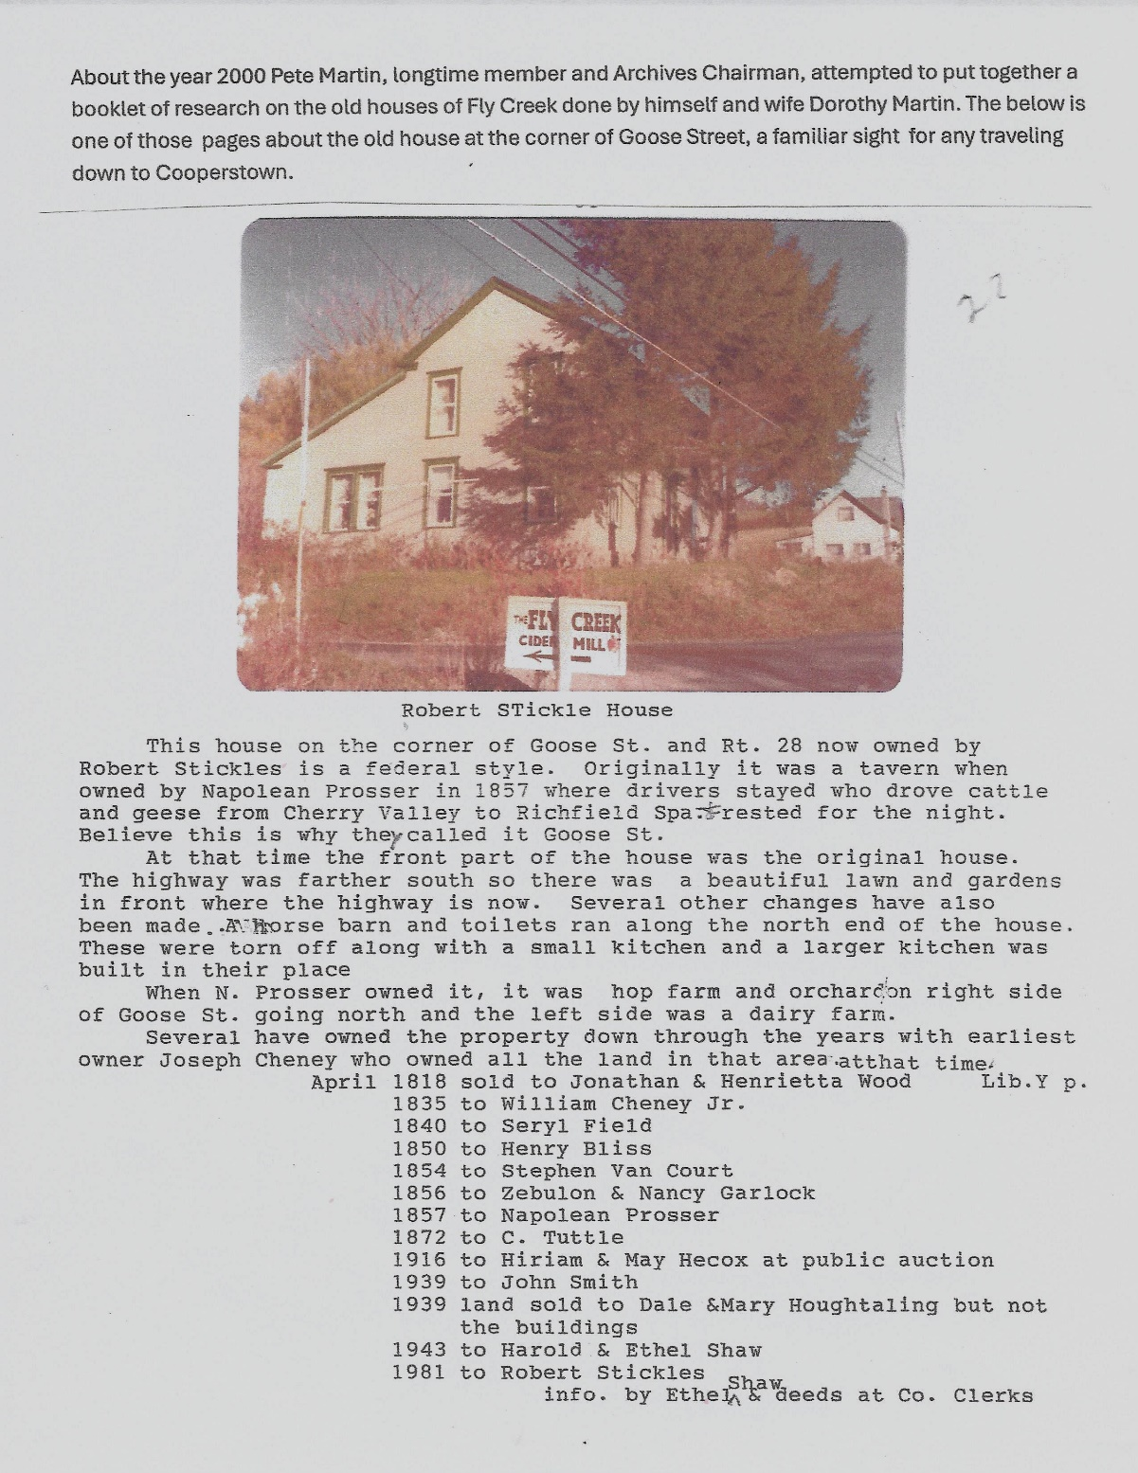

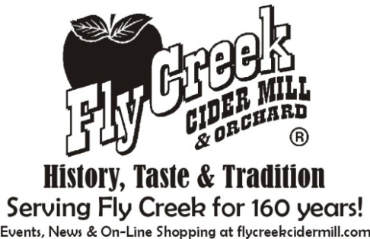 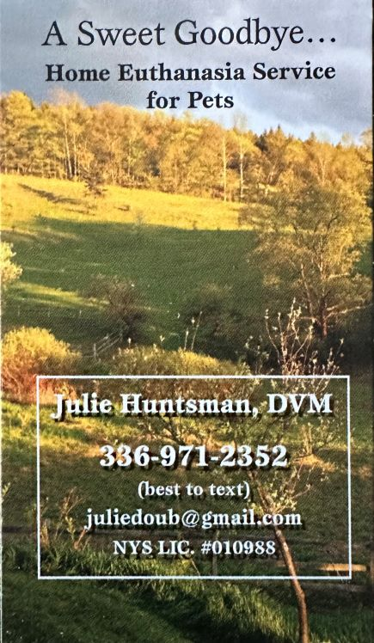 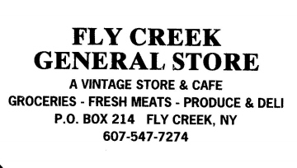

**FLY CREEK AREA HISTORICAL SOCIETY: 2025 ROLL OF MEMBERSHIP**

AINSLIE, Michael

BOURNE, Floyd & Patrice

BROGLE, Kevin

BRUSH, Bart

CHENEY III, Harold (L)

CLARK, Jane (L)

COLLINS, Jr., Perry

CRIPPEN, Katie (L)

CRIPPEN, Tanner (L)

CROWELL, Greg & Helen

*DEANE, Bill

FLY CREEK CIDER MILL (B)

FRESCO, Darshan Newell

HANLON, Carol Goddard

HARRINGTON, Angela E.

HARRINGTON, George & Diantha (L)

HARVEY, Merritt & *Elaine

HAVILAND, Denise & T. A. BUHL (P)

HAZEN, Al & Darlene

HELFAND, Marty

KENNEDY, Pat (P)

KEPNER, Claire (L)

KROKER, Tony & Sharon (P)

MARIENFELD, Frederick & Mary (C)

MILLEA, Denis & Janice

MONTESANO, Dominick & Anna

NEFF, Jean (C)

OKERSON, Elizabeth

OLIN, Gail

PHILLIPS, John & Alison

PRIOR, Patrick & Anne

SANTORIELLO, Sarah Deane

SCHRAM, Michael & Regan

SHARPE, Stuart & Bonnie

SITTLER, Les & Karen (C)

SMITH, Mr. & Mrs. Steven (L)

*SNYDER, Freida (L)

SUSMAN, Liz

THORNE, Judy (L)

VIBBARD, Ronald & Eleanor

WINNIE, Margaret (C)

WINNE, Mary (C)

WOLFF, Margaret (L)

WOODLIFF, Dan

------------------------------------------------------

* = Charter Member

(B) = Business/Professional Member

(C) = Contributing/Sustaining Member

(L) = Lifetime Member

(P) = Patron of History

**MEETINGS & PROGRAMS**

Time to mark your 2025 calendars with the dates of this year’s FCAHS monthly meetings: January 22, February 26, March 26, April 23, May 28, June 25, July 23, August 27 (Annual Meeting), September 24, October 22, and November 19. Meetings start at 6:30 PM; the February and August gatherings will be preceded at 5:30 PM by covered-dish dinners.

The first three meetings of the year will be held in the Fellowship Hall (basement) of the Fly Creek United Methodist Church. In January, Deb McKenzie will discuss “Legends and Leaders of Otsego County.” February will feature our annual “Show & Tell” program; bring along something of historical interest and tell us about it! And in March, Tom Heitz will explain “The Fly in Fly Creek.”

The final two FCAHS meetings of 2024 were held on October 23 and November 20. October’s featured a wonderful and spine-tingling talk by Bruce Markusen, telling “Cooperstown Ghost Stories.” November’s had Jim Loudon screening his excellent documentary about the “Cooperstown & Charlotte Valley Railroad,” spanning more than 150 years of local history.

Following is a list of programs presented at FCAHS meetings in 2024:

**Date Speaker/Presenter Topic**

1/24/2024 Gail Lewis History of Pierstown Grange

2/28/2024 Tom Heitz Susan B. Anthony in Otsego County, 1855

3/27/2024 FCAHS members Show & Tell

4/24/2024 David Wightman A History of Wooded Areas in Otsego County

5/22/2024 John Aborn The Dangerous Victorian House Tour

6/26/2024 Emily Zaengle Vanishing Landscape

7/24/2024 Dan Zimmerman The Emerald Ash Borer

9/25/2024 Martin Tillapaugh Victorian Funeral Customs

10/23/2024 Bruce Markusen Cooperstown Ghost Stories

11/20/2024 Jim Loudon Cooperstown & Charlotte Valley Railroad

--------------------------------------------------------------------------------------------------------------------------------------------

**2025 MEMBERSHIP APPLICATION**

**FLY CREEK AREA HISTORICAL SOCIETY**

**P.O. Box 87, Fly Creek, NY 13337**

Name(s): _______________________________________________________________ Renewal ___ New ___

Address: _____________________________________________________________________________________

Telephone: ( ) - e-mail address: ______________________@_____________________

Please register me as a junior member of the FCAHS (age 21 or under). Enclosed is a check for $5.

Please register me as a member of the FCAHS. Enclosed is a check for $15.

Please register us to a family membership (note: this extends to all family members living in one domicile). Enclosed is a check for $25.

Please accept the enclosed tax-deductible donation, in the amount of $_____ (minimum $30 for individuals or $40 for families), and enroll me/us as a contributing/sustaining member(s).

Please register me as a “Patron of History.” Enclosed is a check for $50.

Please register me for a sustaining business/professional membership (includes a business card-sized ad in the *Fly Creeker*). Enclosed is a check for $90.

Please register me as a Lifetime Member (individuals only). Enclosed is a check for $500 (to be deposited into the Society’s Endowment Fund, or into one of the Society’s general or special funds, at the discretion of the member).

Please accept the enclosed donation, in the amount of $________ toward the building repair fund.

**NEWS BRIEFS (Continued from page 1)**

* **Web Gem …** Book-mark the new FCAHS web-site at www.https//flycreekareahistoricalsociety.org. Keeping it up-to-date will be an ongoing process; feedback, help and ideas are welcome!
* **Jerry Dulin, 1931-2024 …** Former FCAHS member Gerald F. “Jerry” Dulin died in California on August 18. The Dulin family was well-known in Fly Creek, and figure prominently in our book, *Fly Creek Area History*. As Jerry’s obituary said, “He maintained an interest in his hometown of Fly Creek and its Historical Society, and was an occasional subscriber and contributor to its publication, the *Fly Creeker*.” Our condolences to his loved ones.
* **Past Times …** The November 15, 2024 issue of the Oneonta *Daily Star* had a “Step Back in Time” column of local interest, recalling a Fly Creek fire from 25 years ago. On November 13, 1999, Jim Anderson’s Past Times Antiques store on State Highway 28 was victimized by a four-alarm electrical fire, injuring firefighter Tom Steele and destroying the building and an estimated $40,000 in uninsured antiques. Bill Deane recorded the blaze on his camcorder, with footage (along with his bumbling attempt to put it into historical perspective) appearing on Utica’s WKTV news that evening.
* **A Matter of Trustees …** The next quarterly meeting of the FCAHS Board of Trustees is scheduled for April 8 at 3 PM at the Town building. Members are welcome to attend.



**---------------------------------------------------------------------------------------------------------------------**

**FLY CREEK AREA HISTORICAL SOCIETY**

**P.O. Box 87**

**Fly Creek, NY 13337**